Version 2.1.5
We have a new release planned for approximately June 30, 2008. These will be part of that release.

Scottrade wants a new version of the DLL no later than that date. They are interested in adding the OddsMaker to their product. Since I have time, I am fixing bugs before the release. We’ll make a minor release of TI Pro with these bug fixes.

Scottrade ended up sitting on that release for a long time, then requesting small changes. They released version 5.0.0.1 of the DLL on 9/11/2008. That DLL is closer to version 2.2.5 of TI Pro than to this version.

Oddsmaker Confusion
The problem: You are on the configure oddsmaker screen, and you leave some of the fields blanks. What does that mean?
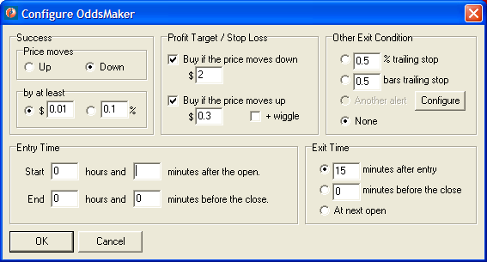

Currently we handle that in an inconsistent way. Consider the “entry time start minutes” field. If you hit okay on the dialog box above, it would work as if you had filled in a 0 and produce the same results. However, if you save your layout and restore it, the blank will be replaced by the default value of 30. This is inconsistent. According to Dan this confuses people.

Solution:
When someone hits OK
If there is a blank field (or a field with an invalid value).
We fill in the field with the default
Else
We close the dialog box in the normal way.

Timer in HTTP Tunnel
I added a timer to the HTTP tunnel. This improves the way we recover from certain types of errors. This is already complete.

Bug Fix: Error Incorrectly Listed as “DNS Error”
Closed, with no code change. Cannot reproduce. I’ve looked at the code. As long as we’ve printed “DNS error” for the user, we’ve specifically checked for a message that said 'connect: WSocketResolveHost: Cannot convert host address' from the library. The code looks good. I believe that this happened as documented, but I can’t explain why or suggest anything else to do about it.

The server was having a serious problem. It kept going down repeatedly. The client incorrectly reported this as a “DNS Error”
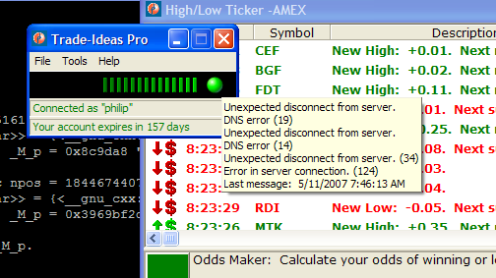

I strongly suspect that this error was caught by an exception handler when we first tried to connect to the server, not in an asynchronous call back. If I remember correctly, I assumed that any error found at this time was a DNS error, since most things were reported asynchronously. I added this specific error message because it was easier to understand.

We need to take a closer look at that code. Is there some way to make a more specific test? Maybe one type of exception would still produce the error message listed above. Any other type of exception would display the exceptions message and class name.

I do not think that I could reproduce the error condition on the server.

Bug: Blank columns
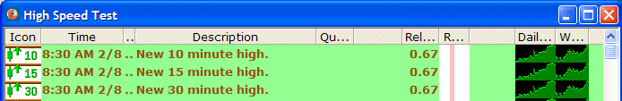
Under certain circumstances the alert window will show blank columns. In the picture above you can see one between the quality and relative volume column. And you can see another one between the range for the day and the daily chart.

Once you see this problem, there’s no way to get rid of it. You can’t delete the column the way that you’d delete a normal column.

In this case I created the blank columns on accident. I had a new version of the software with two new column types. I displayed the new columns in my window. I saved my layout. I went back to an old version of the software which did not have these column types. This window looked like the picture above. I saved my layout again. Then I returned to the newer version of the software. I still had the blank columns.

I saved the original window into a file and reloaded it. The new copy had the same problem. This is what the TIA file looked like:
[AlertWindow]
Top=211
Left=798
Width=696
Height=774
WindowState=0
FontCharset=204
FontColor=0
FontHeight=-13
FontName=Verdana
FontPitch=0
FontSize=10
FontBold=0
FontItalic=0
FontUnderline=0
FontStrikeOut=0
DataConfig=O=7FF9FFFFFFFFFFFFFFFFFFF3FFFFFFFFFF0_1D_0&WN=High+Speed+Test
WindowConfig=C,12,1,40,2,92,3,13,4,202,5,42,0,54,6,41,9,34,0,51,11,45,10,37,0,33,0,1,23,21
Action0=2,4,MAIN LIST
ActionsCount=1

We should always verify the value of the WindowConfig property. This could have been corrupted any number of ways, so we should not trust it.

If we see a column type which is a duplicate, or is out of range, or is the blank type, then we should simply skip that column and move on. If the window has no columns, then we add one column of type blank. (Delphi requires a table to have at least one column.) Any corrections that we make are done silently and automatically.

Possible Bug: Short History vs. Disconnect
Closed. Not a bug. I recorded all message traffic. We are requesting short history exactly when we should be. I suspect this was another issue, like the time that it takes for a bunch of clients to all log in at the same time. We’ve done some stuff on the server side to minimize this, including a script to take down one server at a time.

I noticed that after I reset one of the servers it takes a long time to see short history requests. I suspect I know the cause of this problem: When the server gets reset, all of the clients attached to it are disconnected at the same time. When I try to reconnect, they all request short history, even if they don’t need it. They should be sending their config request for new data without requesting short history.

Again, I don’t have all the facts. But this deserves a closer look.

Adding new alerts causes an exception
When I add new alerts to the live server, and restart it, TI Pro has problems. It generates exceptions and cannot recover. You have to restart TI Pro to make it work again.

This used to work. I don’t know when it was broken. The latest version in CVS (5/3/2008) has this problem. So does version 2.1.4 of TI Pro, which is currently on the web site.

The following describes one way that I saw the problem.

I had test software running on a specific TCP/IP port. This included 12 new alerts not available on the live server. There was no way to reach the test server in HTTP mode.

I started in TCP/IP mode. I was pointing to the test server. Everything was working fine. I could use the config window. I switched to HTTP mode. I tried to bring up a config window. I got an null pointer exception. I got an ugly error window. But the software recovered. I was able to use the config window and the rest of the software.

I switched back to TCP/IP mode. I could not get the config window to work at all.

I switched back to HTTP mode again. Everything worked as expected. The new alerts were not visible, exactly as expected.

I switched back to TCP/IP mode. I still cannot get the config window. Resetting the connection from the main window does not help. Logging in with a different username does not help.

If I restart the software in HTTP mode, I get essentially the same behavior. When I switch to the TCP mode, I can’t see the config window. Instead I get a stream of null pointer exceptions.

Bug Fix: MidStr vs MidBStr
Done but not tested. It seems like I didn’t add any new bugs when running on a US/English computer. But to test this right we’d need to try the http mode, the flip feature, overriding the connection address in the ini file, and many other features on a Chinese computer.

I noticed that we still use MidStr and LeftStr in HttpTunnels.pas. Shouldn’t we be using MidBStr and LeftBStr? This looks just like the bug we fixed in TalkWithServer.pas. It was a bug that only showed up if your default language was Chinese. Presumably this bug will appear if you try to use the HTTP proxy mode and your default language is Chinese.

Alerts are hard to find
These are a couple of suggestions from our old friend cash@metameric.com.

- Make the mouse wheel work in the config window. It should control the scroll bar.
- The should be some way to search for alerts and filters by name. We should discuss this further to develop a good GUI for this.

Bug: Software hangs sometimes (OddsMaker)
I’m pretty sure this one is fixed! I can’t prove it, but I made some reasonable changes, and no one has reported it again.

The changes were based on something that I saw fail in the E*Trade/Java code. Sometimes, after a server disconnect, a piece of code would still have a message id from an old message. It would try to cancel that message id in a new session. That caused a lot more problems than you would think. Now the client keeps a second id which is never reused, and only used on the client. We can now catch that case, and silently ignore the cancel request.

This one is hard to reproduce. Dan sees it a lot. I managed to see it once (but not in the debugger) on my own computer. I just kept running the oddsmaker over and over. I had several windows going at once. Sometimes I’d cancel one and immediately restart it. Other times I’d let it finish on its own.

When this bug occurs, the software will continuously connect and disconnect. If you stop doing anything else, this is what you will see on the status window. The green tick marks will pause for about 30 seconds. They will slowly get dimmer. Then all at once you will see a bunch of new green tick marks. Then it repeats like this forever.

If you try to do work, you will see something slightly different. If you try to run the oddsmaker, it will start okay, but then it will pause, and then restart from the beginning. If you try to run history, it will start okay, but then it will just stop. Real-time data does not come through at all.

Exiting TI Pro and restarting always fixes the problem.

Note: I’m not 100% sure what it looks like. I’ve tried to describe what I saw, but since I can’t reproduce it easily, these details might not all be correct.

From what I’ve seen, it appears to be the case that the client is not sending the requests for new realtime data. So the server is not giving it realtime data. After about 30 seconds of no realtime data, the client breaks the connection. The code was written this way on purpose; the assumption is that there was something wrong with the network connection or the state on the server, so we try reconnecting. In this case that doesn’t help. The problem is almost certainly in the client.

I’ve been through that code several times but I can’t find anything that looks like it could cause this problem.

Version 2.2
The primary motivation for this release was a pair of integration issues. (IB Robot and Assent robot.) However, there are also two major features that will apply to many people (search panel and new view mode). And, of course, some bug fixes.

- The MB/IB robots can now see who paid for the OddsMaker. This probably doesn’t belong in the end user’s documentation.
- StockTickr can now download the OddsMaker directly to their web site without any special debug window or special permissions for the user.
- Bug fix: Removed an obscure bug that affected the OddsMaker but only for people in certain countries. This bug was introduced in 2.1.5.
- Added new mode which sorts by the first time a symbol occurs.
- The scottrade version now uses a different name for the “OddsMaker”. You probably don’t need that in the user docs.
- Added search panel to the config window.
- Added latency report to the status bar.
- Bug fix: There were problems with the context sensitive help for filters if the user used Mozilla.
- TI Pro can now support add-ins. These appear on the Tools menu. This includes the Assent robot. I’m not sure how we plan to distribute these, but by default I suspect that no tools will be packed with TI Pro
- Use the TimeoutMs property from the ini file / main program as the timeout for the HTTP tunnel. – this pretty much applies to one user. He’s using HTTP mode. He has a very slow connection. When we changed the timeout from 10 seconds to 1 second in the last major release, that it impossible for him to use the software. I verified that with a specific release for him. Since he is different from the typical user, this is now a setting in the ini file. This will probably make it’s way to the options window in some future release, but that’s not a high priority.
- Fix a bug in the oddsmaker window. We weren't loading the oddsmaker config correctly when there was an exit alert. – no one reported this alert. I found it myself.

New sort option: first time
In the group and sort mode there should be an option to sort the alert by the first time we saw them. This new field is specific to the client and to the window. If wet get a new symbol, it goes to the top of the window. If we see a repeat of a symbol, it stays exactly where it was.

We update the information for that symbol, and display it in black, just like we do when we’re sorting by any other symbol.

Large numbers of symbols
Question: What do we do when there are more than 1,000 symbols? If there are more than 1000 symbols, then a new one will push the oldest one off the bottom and the next time we see it, it will look like the newest one.

One option is to completely ignore this. It is up to the user to limit his query to something reasonable.

A related option is to allow the user to choose how many symbols to keep in each alert window. This could go on the options window.

Another thought would be to keep all symbols. I don’t like that idea. A related thought would be to store the first times in a different data structure that was smaller and more efficient. That’s possible, but I’m still not crazy about it.

Rationale
The following is a common request. The user wants to see stocks as soon as they meet his criteria, but he doesn’t want to see them more than once.

From: Philip Smolen [mailto:philip@trade-ideas.com]
Sent: Tuesday, April 17, 2007 3:22 PM
To: 'pjs@willcenter.com'
Subject: RE: symbol check

You are correct. You are missing TELA because it is past the second count before it gets to 50,000.

When did you want to see TELA? When it hit twice its daily volume? Or when it got to 50,000 shares?

One option is to create multiple windows, each with a different range for the average daily volume. For low volume stocks like TELA, you could grab everything up to the 10th alert. For higher volume stocks you could grab the 1st and 2nd like you already are doing.

There’s another approach, but it’s a little more complicated. Trade-Ideas Lite can be configured to show you the newest stuff on top, skipping any duplicates. So if a stock hits the 10th level, it will flash, and the number 9 will change to a number 10, but it will not move to the top of the list. The top of the list is reserved for stocks that you haven’t seen before. This is what you’re describing, but it’s a little bit complicated to set up. And it’s not integrated with QuoteTracker. Let me know if you want to try this and I’ll give you more specific instructions.

From: Paul J. Sowell [mailto:pjs@willcenter.com]
Sent: Tuesday, April 17, 2007 2:33 PM
To: 'Philip Smolen'
Subject: RE: symbol check

what i am trying to avoid is seeing the same symbol pop up again and again as it continues to print multiples of its daily volume. Presumably by the time its hits twice or three times its daily volume I would have evaluated it and either have traded it or passed on it. The problem with this, and correct me if I am wrong, is that with a min vol filter of 50K and max count of 2, I will miss something like TELA because by the time it hit 50K the system is probably registering that it is has already done 5 or so times its daily volume. Given what I am trying to do, ie. catch symbols doing big volume and at the same time not weed these out with a filter, is it best to just put in my min volume threshold and not cap the max count?

thanks,
Paul

From: Philip Smolen [mailto:philip@trade-ideas.com]
Sent: Tuesday, April 17, 2007 4:57 PM
To: pjs@willcenter.com
Cc: dan@trade-ideas.com
Subject: RE: symbol check
It’s the latter. It will only show you when a stock is trading 1 times its average volume and again when it is at 2 times its average volume.

What are you trying to do? If you really don’t want stocks that are trading at 5 times their average volume, then you are set up correctly.

If you just had too many alerts, there is another option. You can take a look at the new version of Trade-Ideas. (This is not yet available to the general public.) You can download it from here: http://www.trade-ideas.com/Samples/Setup_2_0_12_Beta.exe. Right click on an alert window, select “View Mode”, “Group & Sort By”, and “Time”.

From: Paul J. Sowell [mailto:pjs@willcenter.com]
Sent: Tuesday, April 17, 2007 6:08 AM
To: 'Philip Smolen'
Subject: RE: symbol check

thanks for getting back to me. As far as the maximum count filter, if i have that set to 2 does that mean it will only show the stock two times, once when it does 1 time its average volume and then again when it does 2 times its average volume?

thanks

From: Philip Smolen [mailto:philip@trade-ideas.com]
Sent: Sunday, April 15, 2007 9:02 PM
To: pjs@willcenter.com
Cc: dan@trade-ideas.com
Subject: RE: symbol check
Hi. This is a low volume stock. There is a conflict between two of your filters. If you raise the maximum count filter from 2 to 7, or just get rid of it, you will see the alert. Alternatively, you could have lowered or removed the minimum volume filter.

You can use the history feature to see this.

From: Paul J. Sowell [mailto:pjs@willcenter.com]
Sent: Friday, April 13, 2007 2:35 PM
To: philip@trade-ideas.com
Cc: dan@trade-ideas.com
Subject: symbol check

Hi, I was wondering why the symbol TELA would not have come up under this alert for friday 4/13.

http://www.trade-ideas.com/View.php?O=40000000000000000000_300_0&MaxCount=2&MaxPrice=0.5&MinFCD=0.001&MinPrice=0.1&MinTV=250000&WN=otc%2fpink3

thanks
Paul

Version 2.4
These are mostly cosmetic changes and small bugs. These weren’t important enough to hold up the release of the new functionality in version 2.1.

Bug in the way we deal with security / vista
We are not saving the windows in the right directory. We should make a sub directory of the user’s documents (like my documents or my pictures) to store these files.

The default windows should be stored in the same place as always. We should include a shortcut from the user’s directory to the shared version. This would be labeled “Default windows” and would give the user access to any defaults that we ship in the install package. This would also allow the user to access any settings he saved in an old version of TI Pro.

Layout Name
When you try to save or load a layout, the layout name field is initially set to DEFAULT_LAYOUT.til. This is not what we want. Each time you save or load a layout, the program should remember that name. The default in the dialog box should be the last name from the last time the user saved or loaded a layout.

We only save one value. The last value saved or loaded is used the next time we bring up either dialog box. It doesn’t matter if the user enters the name in the “save” dialog box, and then brings up the “load” dialog box. He will still see the last value he used in the save dialog box.

We only save the name if the user hits OK.

Note: At one time we purposely added “DEFAULT_LAYOUT.til” as the default. That was before we had all the choices on the options window. Now this is obsolete.

When the program first starts, we still use “DEFAULT_LAYOUT.til” as the initial value before anything is loaded or saved.

If we automatically load a layout at startup, that will replace “DEFAULT_LAYOUT.til” as the initial string. It will work just as if the user had manually loaded.

Fixed and verified.

Save Layout Bug
If you select “Save Layout…” on the menu, and then you hit cancel, you will still see
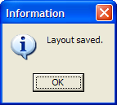
This is confusing and incorrect.

Fixed and verified.

StrategyConfig property doesn’t always work
If you set the StrategyConfig property, that should change the default settings in the OddsMaker. It works when we first create a window; we know that because that’s the only way TI Pro uses that property and it works for TI Pro.

It does not work at certain other times. See revision 1.3 of ActiveX\Exe Container\Unit1.pas for a test case. See http://investorshub.advfn.com/boards/read_msg.aspx?message_id=32440762 for the original complaint.

Presumably this is related to my fix for the “Oddsmaker Confusion” bug, described above, is causing this problem. Every time I display the OddsMaker configuration window, I start by reading the old values from the screen, cleaning them up, and then writing them back. (I added that step to fix the previous bug.) Presumably when someone sets the StrategyConfig property we should immediately update the window with these settings. I have not verified this in the code, but this is certainly the first place you should look for this bug.

Fixed and verified.

Hide Error Message
One time I saw this error message appear in the debug window: “Class=EXmlException, Message=Tags don't match: <SAMPLE></APII0e>, Location=GetAlertData, TAllAlertsConnection.ReceiveGeneralInfo, "<API><SAMPLE_CONFIG>…” Based on the body of the XML document, it looks like the message got garbled somehow.

We should not report this exception to the user. It is confusing and ugly, and it doesn’t help the end user at all.

I think we already have retry logic for this specific message type. At one time it would retry every few seconds. If the message is garbled – if we catch any unexpected exceptions, we should retry in a few seconds just like if the message handler reported an error.

Note: I’m only talking about this one occurrence. A while back I added code like this to several parts of the code. Pretty much any time we get an unexpected exception, I display data to the debug window. For the most part that’s a good thing. I only want this one specific case to be changed.

On a side note, I’m sure why this happened. I’ve only seen it once.

Here’s a more complete look at the bad message. Clearly something is wrong with the message.
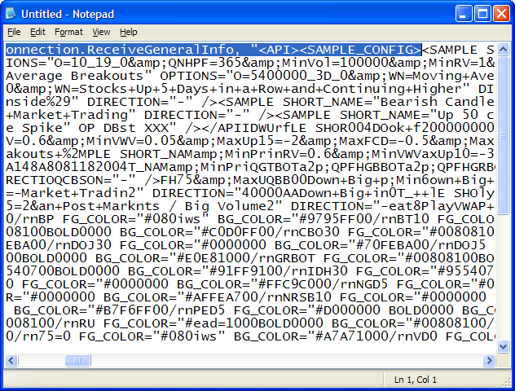

“Group and Newest Symbols First” mode is backwards
Assume that the alerts are going down. In the default, “Newest First”, mode a new alert is always displayed at the top. In “Group and Newest Symbols First” mode new alerts are usually added to the bottom. As long as each alert has a different symbol, the new alert will always be on the bottom.

You can work around this by changing the direction to up. But that’s confusing. It should go in the same order as the default mode.

Fixed and verified.

“Casino Factor” in Scottrade
Scottrade users (i.e. DLL users) will see different slightly wording than TI Pro (or other ActiveX) users. Currently this works, but the code needs to be cleaned up.

Some of this wording comes entirely from the client side. See revision 1.21 of AlertPanels.pas for part of the change. It creates a variable, but leaves the default the same as before. The DLL specific part of the code changes this value. This part of the code is good and does not need to change.

Some of the wording comes from the server. In that case the client has to send a special request to the server. By default the server will send the traditional wording. Because I was in a hurry, I hard coded the change. See revision 1.10.2.2 of OddsMakerConfigWindows.pas. This works, but it will be hard to maintain.

Please change the code so that we get rid of that branch. This should be a configurable choice in the common part of the code. The DLL specific part of the code should override the default. This should work just like the part in AlertPanels.pas, described above.

Fixed.

Add TimeoutMS to the GUI
Starting in version 2.2 of TI Pro, the TimeoutMS property is more important. This should be added to the options window, in the HTTP Tunneling section.
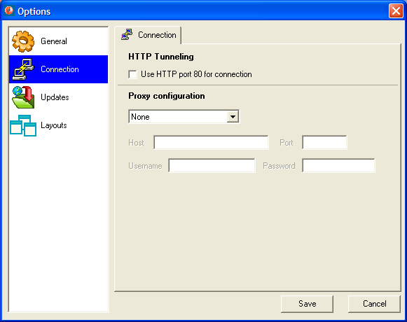

This is only meaningful if HTTP Tunneling is enabled. (That’s not 100% true, but you can pretend that it is.) So the controls for this should be disabled if HTTP tunneling is not checked.

Proposed GUI: Use a slider bar to select the value. The minimum should be 500 and the max should be 10,000. Use a label to display the results.

The value in the ini file and in the property is measured in milliseconds. The limits listed above are in milliseconds. What we display on this screen should be in seconds. For example: “0.500 seconds”.

If the user modifies the file, he can put in an invalid value. I recommend setting this value to 10 seconds if it was bigger than 10 seconds, and ½ second if it was less than ½ second. That only applies to this window. The networking part of the code already has its own safety checks.

Fixed and verified.

Add Price Column
More details to come. This will come from the server as part of each alert. We shouldn’t have to do any math or anything.

We might want to format this in a slightly different way than the other columns. If the price is >= $1.00, then we’d display two places after the decimal point. If the price is < $1.00, then we’d display 4 places after the decimal. I’ll have to check if a negative number could occur. That certainly wouldn’t be the common case, but I think that something like this is possible. In that case, we display for digits if the absolute value of the prices is less than 1.0.

In the Form Builder

Icons in Form Builder
When I install the ActiveX control into Delphi, our controls have very generic icons. There are defaults that came from Delphi. We need to add real icons. I don’t know how to do that! I haven’t created any icons yet, but that should be easy.

Fixed and verified.

Selecting and Moving in Form Builder
When I add on of our ActiveX controls on a form it does not act right at design time. When I click on it, Delphi doesn’t select it. I can’t drag it either. I can use the squares at the corners to resize it, and I can set properties using the object inspector. So it’s got enough functionality to be usable, but it is not as nice as most controls.

This comment applies to the alerts control and the status bar. It might apply to the others, too, I’m not certain.

Leonid does not think this can be fixed.

GenericNetRequestX.Visible
The “visible” property on the “GenericNetRequestX” ActiveX control does not appear to work right.
- The object is always visible at run time.
- If you set the visible property to false, the object becomes invisible at design time!
This is exactly the opposite of what it should do!

Configure Another Alert is not initialized properly
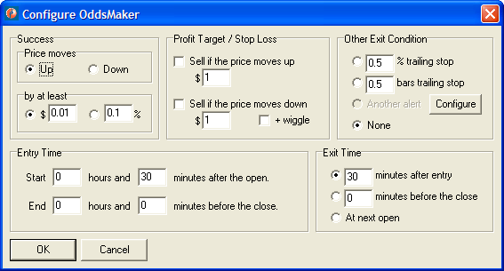On the “Configure OddsMaker” window you can hit the “Configure” window to bring up a config window.
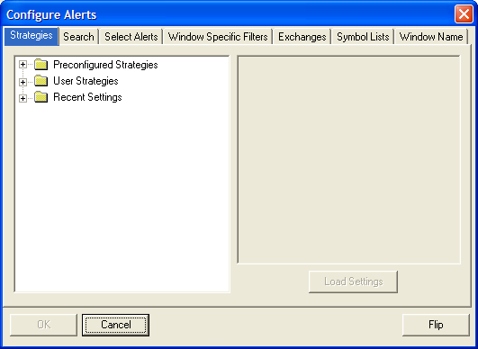

This mostly works, but it doesn’t always initialize the config window properly. Notice that there is no “Current Settings” in the list of strategies.

Note: Sometimes there are no current settings. In that case, the configure alerts window is already correct. We already know exactly when we have current settings. If “another alert” is disabled on the “Configure OddsMaker” window, then the alert configuration screen above is correct. When “another alert” is enabled, then we should see the current settings.

Network Test Program - Reading the Proxy Settings
Currently I see some odd results in the network test results. For example:
- SUCCESS: WinInet Proxy Name = " ".
- FAILURE: Auto-Proxy Script URL not found.
- FAILURE: Can not initialize Auto-Proxy library.
In these cases we should report SUCCESS, and say that we cannot go any further. (You can add whatever other information you find helpful.)

If we actually see get some proxy information, then we need to go further. In that case we should try setting the proxy information and repeating on of the standard HTTP tests.

Improve the way we periodically refresh the icons
Once a day we should check for new charts. Ideally this would be in the middle of the night, right after the server creates new charts. Ideally the server would tell us the right time.

This was discussed in more detail in an email. I also added related comments to TAllAlertsConnection.ReceiveGeneralInfo in GetAlertData.Pas

Needs discussion.

The status window doesn’t look good in different sizes
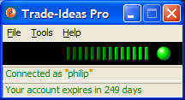
The green bars should go further. At a minimum, they should be as wide as TI Pro’s main window. Of course, TI Pro is not the only software using this ActiveX control, and some people make it much wider than this.

Originally I limited the number of green tick marks to a fixed number based on two things. First, I wanted to make this efficient because it updates 10 times each second. Second, I thought that I knew the most green tick marks that you could see before they turned black.

The software has changed a lot since I made that decision. We now request real-time data twice as fast as before. We also have a lot of additional message types, so there is no real upper limit to the rate at which the new tick marks appear. Efficiency, however, is still a concern. Maybe we can use a dynamic array to store the brightness of each tick mark. When the user (or the host application) resizes the window, we resize that array.

There are also problems when the window is too short or too tall. Sometimes we see a scroll bar. That is not right. The items should always be vertically centered. If there is not enough space, then part of them gets cut off. We don’t scroll or resize, we just clip.

(We want to do a very good job even if people make the control very wide. We want to encourage people to use the standard height for the control. However, if someone gets the height wrong, we want to do slightly better than we are doing now.)

Make the background pattern scroll better
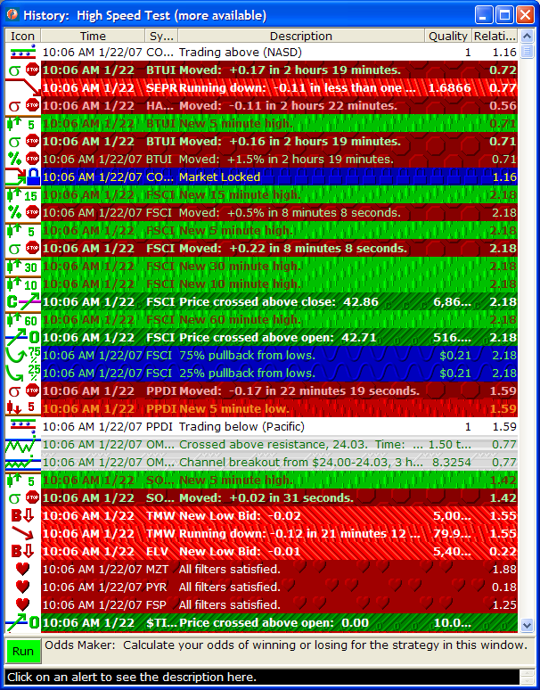
Sometimes we display a pattern for the background of a cell in the table. This looks good in (almost) any static picture, like the one above. But the effect is incorrect when the user adjusts things with the scroll bar or when new data is inserted at the top.

Notice that we always draw the pattern starting from the top of the window, not the top of the cell. In the picture above, this is most clear with the “stop” alerts. Look closely at the rows with the red octagons. On the first example (from the top) you see about 1/3 of an octagon on the top row. On the next example you see a little less of the top row of octagons. On the next example you see even less. When you go to the middle of the window you see that the entire first row of octagons has disappeared, and we’ve sliced a small part of the top of the next row of octagons. In the last example, we’ve sliced off slightly more.

We do this on purpose. Look at the two rows of octagons that are adjacent. They perfectly fit together. You can’t tell where one row ends and the next row starts. That’s what it’s supposed to look like.

The problem becomes visible when you scroll.
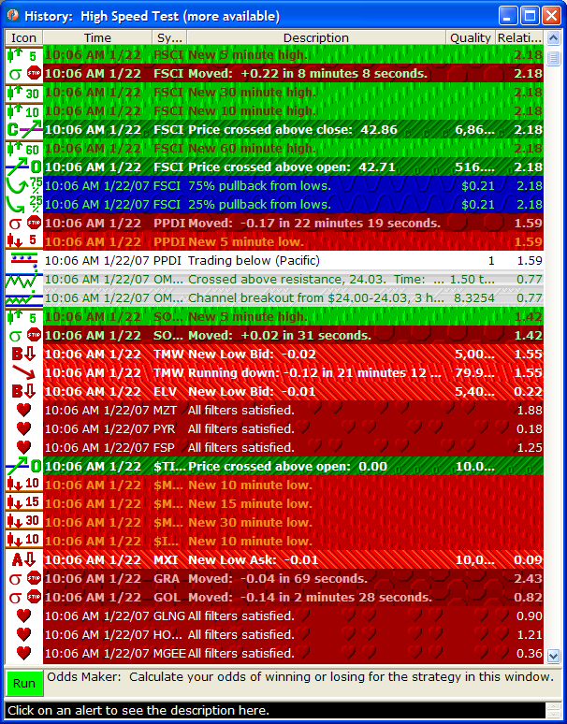
In this picture I scrolled down 10 lines. Look at the second row in this picture. The text in the second row of this picture is the same as the text in the 12th row in the previous picture. But the background pattern is different. The background pattern in the second row of this picture looks exactly like the background pattern in the second row of the original picture, but it should like the background pattern in the 12th row of the previous picture.

The difference that I’m describing is subtle, but important. When you use the scroll bar, it should be obvious that things are moving. Sometimes the text in each row looks very similar. By moving the pattern the way that I’ve described, we will be giving additional hints, and the scrolling motion will be more obvious.

We see a similar effect when new data is added to the top of the screen, pushing the old data down. In fact, you could get from the second picture to the first picture by receiving 10 new alerts. Again, we want the pattern in a cell to be drawn the same way even when the cell moves. In fact, I think it’s even more important here, when we get new alerts. The data in the window should look like it’s moving down as new alerts are added at the top.

The same thing happens when new data is added to the left, pushing the old data to the right. We also want to fix that problem. The details will be slightly different when the data moves in from the right or from the bottom. And, of course, historical data fills in from the opposite direction. And this should work with both the horizontal and vertical scrollbars regardless of where the new data is added. In any case, the way we draw the background in a cell should always follow the text and data in the cell.

Note: The previous picture also shows a related bug. Look at the last two rows of octagons. These don’t line up like in the first picture. This is a painting problem. I forced this window to repaint by covering it with another window. After it repainted, it looked like this:
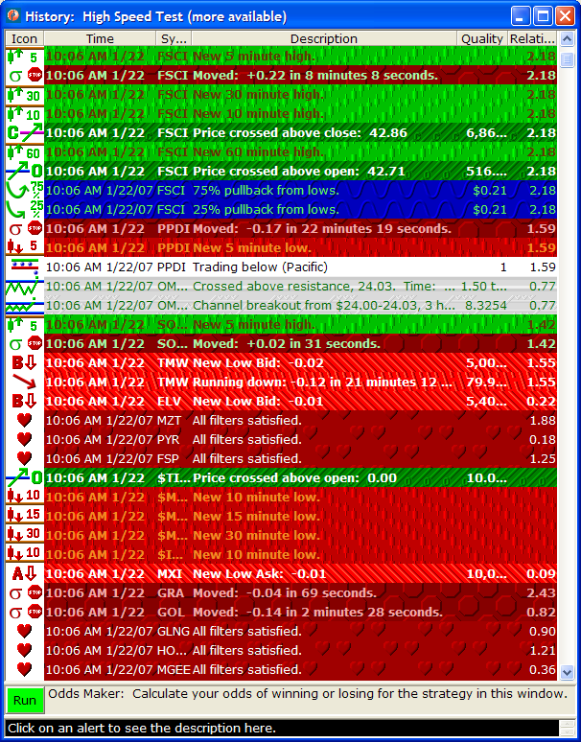
In this third picture you can see that the pattern in the last two rows lines up, just like it did in the first picture. The bottom three rows also show the same problem in the second picture, and that problem is also fixed in the third picture.

This problem is caused by an optimization in Delphi and/or MS Windows. The code assumes that when you scroll, you will repaint each cell in exactly the same way, even though the cell moved. (This problem only occurs when you manually scroll; when we add new data we always repaint.) I suspect that this bug will automatically go away when we fix the scrolling, as described above. We need to verify that the bug is fixed. If it’s not fixed automatically, then we need to go ahead and fix it.

Note: If I remember correctly, when you draw the pattern, you specify the offset in pixels as a 16 bit number. That is much too small to use directly. A normal alert window can use more than 2¹⁶ pixels for new data in a very short time. Depending on your font size, you can easily use more than that many pixels just with the scroll bar. You should store the total number of alerts received in a 64 bit integer. You should do the modulo division yourself to make sure that the pattern is in the correct place. Note that the size of the pattern and the font size can change between calls to the paint method. Note that different cells can have different patterns with different sizes.

Leonid changed this, but I still don’t like it.

Replace several menu items with one dialog box.
The pop-up menu for the alert window is getting too long. Several of the settings should be moved into one dialog box. The dialog box should use tabs to organize the large number of items in it.

Pretty much everything that is part of the WindowConfig property, everything that gets copied when you say “Duplicate” window, will move to this dialog box.

I’m only talking about items that are built into the ActiveX control. For simplicity we will not consider any items that come from the host application.

View Modes
New requirement 10/9/2008
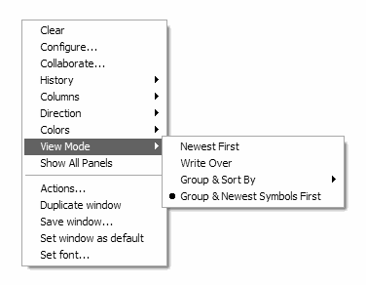
Currently the menu lists four different group modes. The last item, “group & newest symbols first” should not be on the same level as “newest first” and “write over”. It should be listed with the other “Group & sort by” choices.

This doesn’t need to change immediately. Please change it at the same time as you move this menu item to the dialog box.

Add a way to configure the time format
There is a property in the ActiveX file which allows you to select the time format. For example, do you display AM and PM or 24 hour time? Do you display the seconds? The date?

This feature works great, with one problem. The rules for this property are very complicated. They are based on the rules for Delphi’s FormatDateTime function. The user can list several formats. The ActiveX control will go through the list looking for the first format which will fit.

We need some type of GUI on our options window which will allow users to select appropriate options.

Ideally the result would be in the local.ini file. A few people have actually set this value. (Most people use the default, and nothing is listed in their local.ini files.) Also, if someone wants to use that ActiveX property in a different application, they can use TI Pro to select a format. Then they can copy the value from local.ini to their own program.

Change the way we present multiple windows.
Make this an option: you can choose the new way or the traditional way. In the “traditional” way, if you minimize the main window, you minimize all windows. In the new alternative, most windows are normal windows that appear in the windows task bar. The main window can minimize to the windows tool tray to show status but take less space.

This will require changes in the ActiveX. The Connection Control object should have a new Boolean property. If this is true, we display constant status in the tool tray. This can be modified at run time by the host application. (This allows it to disappear when we are displaying the full status window in TI Pro.) And it can go into the standard Alerts.ini, for the old applications which have not taken advantage off this yet.

We will need to add some callbacks so that the main program knows when the user double clicks on the icon.

Let users select their own colors.
There should be an easy way (i.e. a GUI) in TI Pro to allow the user to create and modify their own color schemes.

An interesting idea is to tag each of the alerts on the server as bullish, bearish, or neutral. Then a user only needs to select 3 sets of colors. E*trade has asked for something similar.

New: On the server side we now tag each alert as bullish, bearish, or neutral. This is visible in the search panel of the TI Pro config window. Presumably the server would send this data in a better format for the sake of this feature.

Better Name and Icon for the Task Bar

I was running Main Alert. This is a customized version of TI Pro. Normally I see the correct name and icon for this program. But not always.

When I bring up the config window, and the task bar is already full, I see the picture above. Windows is using the original icon and name. Is it possible to fix this?

I think the name comes from the filename of the exe file. That seems easy enough to fix and test. The install script can change the name to Alerts.Exe, or something custom for each installation.

Is it possible to fix the icon? I do not want to rebuild the software for each customized version of TI Pro. Ideally we’d show the correct icon at this time, the same icon as we display everywhere else in the program. If that’s not possible, we should find a very generic icon, and use it in these situations.

One more observation: When I run the normal TI Pro, and I set up the same circumstances, I don’t see this icon. In that case I see the default Delphi icon. That’s very strange and unexpected. I would expect both versions to act the same in this case.

DDE?
We need some good way to send symbols continuously to other applications. Excel is a common request. I assume DDE is the best way, but some similar standard could also work. This should be added to the actions for alerts window.

All time highs and lows
When a stock is trading on all time lows we say that it is trading on the lowest value in the last 384 days. “384 days” appears in the quality column. TI Pro naively copies that from the server and displays it in the quality column.

It would be more accurate and less confusing if we said something like “> 365 days” any time the number was greater than 365.

It’s not completely clear how TI Pro would know about this new rule. Something might have to change on the server side to give TI Pro additional information. Or TI Pro might just recognize this special case and have the number 365 hard coded into it. We need to decide.

Saving files on a computer with limited permissions
On some computers a normal user cannot write to files in the program files directory tree. We could solve this problem in a number of ways. My preference is to move the files to the My Documents directory.

The following discussion lists several known problems and a few possible solutions. I don’t think this covers all of the problems. What about local.ini? What about things that we save to the registry?

Also I'd like to point you on some issues regarding saving layout (and any other information) to files. Did you remember UBS? They have had problems because they do not have administrative privileges on their PC. Hopefully, I've resolved the problem with check of ActiveX version, but there are others. They do not have write access to the \Program Files\Trade-Ideas Alerts\ folder, and thus they can't:
1) Save any changes in Options window of TI Pro which are written into Local.ini;
2) Execute "Set window as Default" command, which writes DEFAULT_WINDOW.tia file;
3) Save alert windows and layouts to files in \Program Files\Trade-Ideas Alerts\, although Windows informs them about the problem when standard Save dialog is executed and asks for alternative - save files in user's My Documents folder.
I do not know, how many customers will be affected by this issue, but probably we need to think how to process it.
There are several possible ways:
1) We may just point in the documentation that system administrator who installs the system on user's PC should set write permissions to \Program Files\Trade-Ideas Alerts\ and all subfolders for all users who will use Trade-Ideas Pro.
2) We may implement automatic creation of shared folder \Program Files\Trade-Ideas Alerts\ during installation (which must be executed by Administrator) with write access for all users of the local PC;
3) We may update the implementation of TI Pro so that it will store all configuration files and saved files in the My Documents/Trade-Ideas folder of the current user, if that user do not have Administrator's privileges.
Variants 2) and 3) requires additional research and coding.
I don’t want to worry about these issues in this release. I’ll add it to our notes for next time.

Your 3rd suggestion makes the most sense to me. Some programs always create a folder in “My Documents”. (Skype does this, and so do some versions of Delphi.)

Maybe we keep the existing files and folders as a template for new users. When a user starts TI Pro, we check for the folder in “My Documents”. If it doesn’t exist, we create it and we copy the stuff from the TI Pro folder. I like this because it works for new users, and we don’t have to do anything special for current users who are upgrading. They will get a copy of their existing files.

This is really a weird case. Very few of our users have permissions like UBS. However, a few people who are making decisions on big contracts are set up like that. (The same people typically need the HTTP proxy.) UBS isn’t even planning to give TI Pro to their customers. This is just a way for them to decide what they think about the product. If they like it, they want one big feed from our server to their server so they can redistribute it to their users themselves. That’s why I don’t want to put a whole lot of time into this.

Detecting a missing ActiveX control
Our code for detecting a missing ActiveX control does not seem to work as well as it could.

I removed a version of TI Pro from my computer. Then I ran the robot. It crashed in a bad way. It did not detect the problem. Then I tried running TI Pro, because that code was copied from TI Pro. TI pro complained about the missing generic connector. (The Robot does not use that component.) Then I removed a different version of TI Pro from my computer. I ran TI Pro again. This time it crashed in a bad way.

I used the control panel to remove the software. However, this was all on my development machine. So other strange things could be happening.

When I searched the registry, it knew about several versions of the ActiveX control, as shown here.

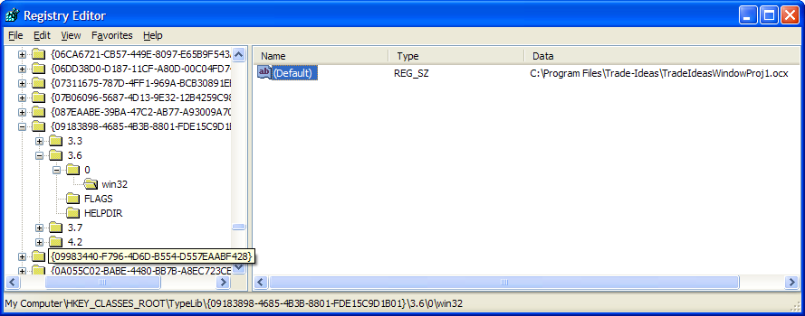

Delphi correctly detects the problem. It shows me the following message:
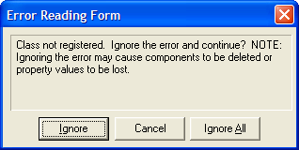
So Delphi must be doing something that we are not doing.

After this I installed an old version of TI Pro. Then our test worked as expected:
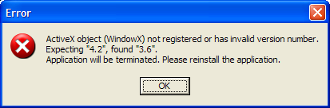

I uninstalled the old version of TI Pro and tried to run the robot again. The I got another bad exception: 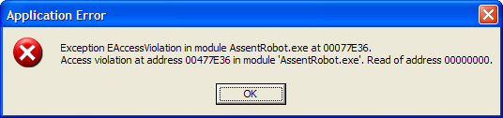

After reloading the newest version of TI Pro I see an additional version of the ActiveX control in the library.
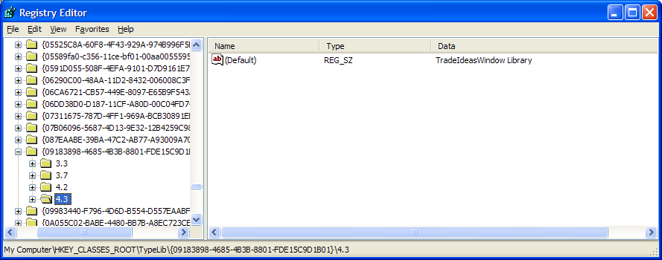
This gives a good hint at what’s happening. On my computer presumably I didn’t uninstall the old versions correctly.

This is something of an odd case. I don’t know how important it is. I don’t know how many real users would see this. But, as I said, Delphi can handle it right, so we should be able to do better.

Fixed and verified.

Resize / Repaint / OddsMaker bug
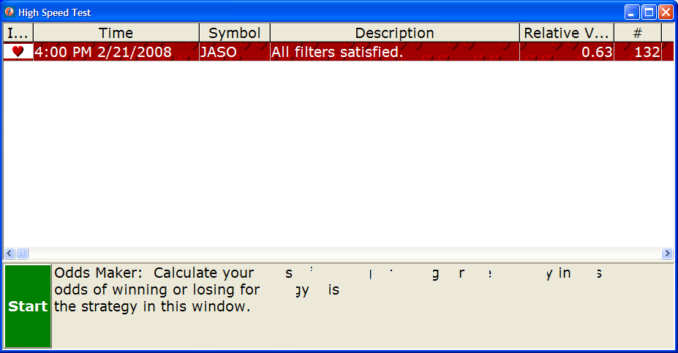
When you change the width of the alert window, the OddsMaker panel is not very smart. Notice in the picture above that the left third of the text would look normal if you saw only that. Originally the window was exactly that width. When I stretched the window, the TRichEdit should have repainted itself from scratch. Instead it redrew a few small bits and pieces, making things inconsistent.

Clearly we need to grab the resize event and send our own invalidate command to the TRichEdit control. Presumably this is a work around for a bug in Delphi and/or Windows.

Can you reproduce this? I’ve had strange issues with the TRichEdit in the past. There are multiple versions of that DLL delivered with different versions of Windows.

This problem actually comes and goes on my computer. I don’t know what creates the problem.

The problem is most obvious when you make the window wider, but there are similar problems when you make the window narrower. If you move the splitter to change the height of the panel, it redraws correctly. In certain extreme cases you can make the size of the panel change by changing the window size. We should test that case, too.

Long Term

Possible bug: Direction seems to change.
I’ve noticed that the direction of the alerts seems inconsistent. Various view modes are not consistent with one another. For example, If you have the same direction arrow on two identical windows, and you say to sort one by the first time and the other by the most recent time, they will display results in opposite directions. History vs live also seems to have similar troubles in some modes.

Here’s a related email:
From: Andre' [mailto:loanme5@gmail.com]
Sent: Thursday, March 05, 2009 5:59 AM
To: info@trade-ideas.com
Subject: Direction

Hi,
My symbol list "direction" changes every time I run history or save contents. I do not remember having this issue in earlier versions. Is there anything I can do about it?
Thank you,

Fix history for various viewing modes
This was never really spec’ed out very well. The basic idea was that you could have a real-time window running all day, and next to it you could bring up a history window. And they would look the same. It seems we are not doing that. Here’s a suggestion from Brad based on several users’ suggestions.
From: Brad Williams [mailto:brad@trade-ideas.com]
Sent: Monday, March 02, 2009 8:49 AM
To: 'Philip Smolen'
Subject: Sorting option

Phil,

I need to be able make a historical scan request that will allow me to sort based on symbol (we do that) AND show me the LAST time it triggered; not the FIRST time it triggered. Perhaps a GROUP and SORT BY → SYMBOL (LAST) in addition to SYMBOL (FIRST).

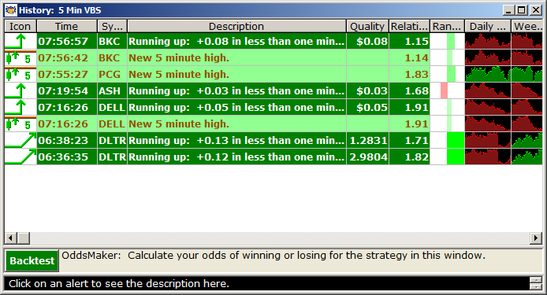

GROUP AND SORT BY SYMBOL RESULT
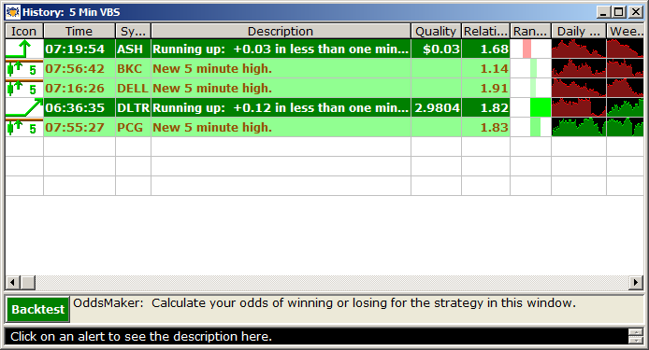

Make sorting more obvious
If you are sorting by a column, there should be an arrow showing which field is being sorted, and the direction.

Maybe, double-clicking on a column puts you into that sort mode.

Not a substitute for the dialog box. These are additional hints to make it easier to use.

Requested by brad. This is most important for history. Not for live data.

Make config window resizable
It would be nice if we could resize the config window. In particular, it wouldn’t be that hard to make the window taller, and keep the width the same. That would help Pristine a lot because they have a lot of strategies.

If we could resize the whole thing, that would be good, too.

Also, if it’s not too hard, it would be nice to be able to resize the contents of the strategies panel. Drag the separator between the list of strategies and the description of the strategies.

Show current settings in the config window
The strategies panel shows a summary of the filters and alerts in a given strategy. That includes the predefined strategies and the previous strategy. The window name panel shows a list of items that have been changed. The window name panel should also show the current settings. This would look a lot like the strategy panel. The list of changes can get too long and hard to read.

A movable bar could allow you to separate the list of changes from the list of current items. Then the user could pick which he cares more about.

Improvements to the Search Panel
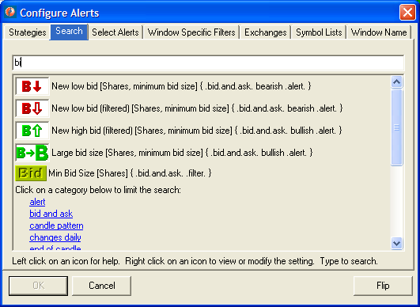
The functionality of the new search panel is all there. It works. But there are a few changes which could make it look better. I haven’t done any of these because I didn’t see any easy way to do what I wanted.

A TRichEdit seems like the best match for what I want, but I’ve had lots of problems with that control. The search string would have to be a TRichEdit, and the description of each alert and filter would have to be a TRichEdit.

Displaying Categories
Each alert or filter gets words from different places. We start with the name of the alert or filter. We have a description of the alert filter, or the units for the window specific filter in square brackets. In curly brackets we have key words and categories. A category is an entire phrase which should be treated as one single word.

Currently we use periods to create a category. For example, you can type “.bid.and.ask.” and the software will look of everything that is tagged with “.bid.and.ask.” We also display the phase the same way in the curly brackets, to help the user understand this. We also list the categories at the bottom, as hyperlinks, to make it easier to search for them.

This was a quick and dirty trick. It works, but we can do better.

Ideally we’d be able to display the categories like hyperlinks, and to do it right next to the icon. Instead of saying “.alert.” next to each icon, we’d say “alert”.

This formatting is not limited to the section with the icons. Ideally the categories would be drawn the same way at the top. I have no idea what type of control to use there.

Ideally, we’d be able to click on the category name at the top, next to the icon, to search for it. If we did this, we could remove the list of categories from the bottom.

Clicking should not be limited to categories. You should be able to click on any of the words describing an alert or filter, and have that word added to the search string.

Typing
Ideally, any time you type, that should add the letters to the search string. If we can’t do exactly that, we could at least do a better job of putting the focus on the input box for the search string.

Removing a Search Term
Currently, if you click on a category twice, it will be added to the search string twice. If you click 10 times, it is added 10 times. Ideally if you click on a category a second time, then it should be removed. If you click on it a third time, it is added back.

If we allow the user to click on other words, not just categories, the same rules should apply.

Add Network Auto-Detect Feature
I think this requirement is dead. E*TRADE does this. I like the idea, but I think it causes more problems than it solves.

I’m still working on this requirement. Please do not change the code yet. E*trade recently released a version of our code, and they added their own network auto-detect feature. Sadly they are still having problems. The code works as designed, but their network administrators have started blocking more things.

Note: This must work for all applications that use the ActiveX control, not just TI Pro. However, TI Pro will add this to the Options window to make it accessible.

Note that there are two different things that we are detecting. We might detect the proxy settings, based on the code that you recently added to the network test program. We might also try to determine if we need the HTTP Tunneling mode or not. If we do both, we have to check the proxy settings first.

The HTTP tunneling should work similar to the proxy settings. By default we try to decide on our own. But the user can force it to go one way or the other.

How do we automatically choose HTTP tunneling vs TCP/IP? The networking part of the code already has a callback each time that it receives a message from the server. (That’s how we display the yellow and green tick marks.) If we receive at least one message from the server using TCP/IP, then we assume that TCP/IP is good. If we try to connect to TCP/IP, but we encounter an error before we receive our first message, then we try HTTP next time.

Note that errors can come from a lot of different places. In particular, don’t forget the timeout. Sometimes the networking code thinks that everything is okay, but GetAlertData.pas will say that that it has been waiting too long.

If we tried HTTP last time, and there is any type of error, then we automatically go back to TCP/IP. Note that the Reset and SoftReset functions are not necessarily errors. If you change your username, we will try to reconnect again, but that’s not an error.

Do we need a button on the options window that says “check now”? I’m not certain. Are we redoing the complete auto-detect procedure each time we get disconnected? We should do it at least once each time we restart the software.

We originally discussed doing some of these tests when we first install the software. I don’t think that’s a good idea. For people with a laptop computer this can change at any time.

Perform the DNS lookup in the background
This requires more research before we do it. If this starts another thread, it’s a bad idea. I’ve had problems starting my own threads in an ActiveX control.

Our networking library does most of its work in a non-blocking / asynchronous fashion. By default, all DNS lookups are done immediately, in a blocking / synchronous fashion. We need to change the software to do the DNS lookups in a non-blocking fashion.

The documentation that comes with that library describes how to do this. This will require more work than the way that we’ve done it currently, but the library appears to have all the functionality that we need.

This applies to the WSocket component and to the HTTP component.

This problem has been a very low priority for a long time. The reason is that I’d never seen the problem first hand. A DNS lookup for www.trade-ideas.com works quickly. Even when it fails, it usually fails quickly.

I finally saw this problem when I was attached to a VPN. I had perfect connectivity to this network, but the attempt to resolve www.trade-ideas.com took a long time before finally failing. Trade-Ideas Pro failed in a miserable way. It would hang for long periods of time. I can reproduce this at will.

I suppose this could also happen with an address pointing to a bad DNS server. I’ve seen this before. Some names take a long time to resolve. I didn’t think to write down any of these bad names. If it will help I might be able to find more examples.

Now that I’ve finally seen this bug, we should fix it.

Add scripting to TI Pro.
It seems that a lot of people are rebuilding the whole application when they just want to add one little feature. Then they have to worry about things like the symbol list editor and the external linking.

This also might allow us to add some complicated features that most people don’t need. Things like cascading alerts. (If we see an alert in a specific window, add it to a specific symbol list.)

Note that we now have the ability to embed a DLL into TI Pro. This might solve some of these problems. We might not need scripting. Or maybe one or more DLLs could add scripting in different languages.

Convert Stock Symbols
Stock symbols are not the same everywhere. The major US markets are pretty consistent. But as soon as you look at the minor markets (i.e. the “pink sheets” or “bulletin board” stocks) or stocks from other countries you have trouble. Most software will add something to the end of the stock symbol to say which exchange it comes from. While the basic symbol stays the same, these suffixes differ from one platform to the next.

This is an example of a problem that I might want to solve in the scripting language. There are just too many different things out there. I don’t want to re-release TI Pro for each one. And I don’t think a simple data file (without scripting) would be sufficient.

We’ve known this was coming for some time. We’ve been ignoring the problem so it would not stop us from making progress on other exchanges. But I’m sure the following email is just the first of many to come.

From: Philip Smolen [mailto:philip@trade-ideas.com]
Sent: Wednesday, June 28, 2006 10:21 AM
To: 'Jonathan Nzouankeu'
Cc: 'support@trade-ideas.com'
Subject: RE: TSX symbols from Trade-Ideas

Hi. “CAT” refers to the Toronto Stock Exchange. “CAV” refers to the TSX Venture Exchange.

Linking between Trade-Ideas and other platforms will be difficult because these extensions appear to be different in each piece of software. We are looking at the problem. (We know it’s going to get worse as we are moving into more countries and more exchanges.) But at this time we do not have a solution.

Sorry about the inconvenience. Thank you for your feedback.

From: Jonathan Nzouankeu [mailto:jonathan.nzouankeu@sympatico.ca]
Sent: Wednesday, June 28, 2006 5:24 AM
To: Philip Smolen
Subject: TSX symbols from Trade-Ideas

Hello Philip,
I usually trade the US market (Nasdaq, Nyse and Amex).
I'm exploring TSX and the symbols I'm getting from Trade-Ideas have a CAV or a CAT extension. I'm confused by the extension and I'm not sure how to get those symbols understood by my trading platform.
Would you have any information on the TSX symbol terminology?
Many thanks...
Jonathan

OddsMaker exit alerts
- OddsMaker – if you have an exit alert, you should be able to see it the next time you hit configure.
http://investorshub.advfn.com/boards/read_msg.aspx?message_id=34959502

Save Contents… vs. QuoteTracker
The “Save Contents…” menu item should be available in QuoteTracker.

At one time I made sure that this menu item was not available in QuoteTracker. QuoteTracker requires that we give them a callback with the window handle each time we create a new window. I didn’t know how to do that with a File Save dialog box, so I removed the menu item.

It’s actually quite easy to get the window handle for a standard dialog box. See the TD Ameritrade robot if you need an example.

So the Save Contents… menu item should always be present, just like any normal menu item. We will never want to return to the old way of doing this. So you can also remove a lot of obsolete code when you do this.

New information (1/21/09):
See the way we fixed it in the TDA robot. It’s not beautiful, but it works.

New information (6/13/08):

When I saw the properties and events for the dialog box object, I assumed that it would be easy to fix this. I did the obvious thing, and it didn’t work.

I sent an email to the Medveds asking them what they do. No response yet.

I suppose we could still fix this. We’d have to replace the standard dialog box with one of our own.

These are the changes I made. When the normal callback didn’t work, I added code to make the window always-on-top myself. When that didn’t work, I added the same code to a window of my own creation, and that worked as expected.

cvs diff -u -wb -- AlertGrids.pas (in directory C:\Documents and Settings\Philip\My Documents\Borland Studio Projects\Skunk\ActiveX\Main Body\)
Index: AlertGrids.pas
===================================================================
RCS file: /var/cvs/TradeIdeas/ActiveX/Main Body/AlertGrids.pas,v
retrieving revision 1.41
diff -u -w -b -r1.41 AlertGrids.pas
--- AlertGrids.pas 11 Jun 2008 16:49:50 -0000 1.41
+++ AlertGrids.pas 12 Jun 2008 17:17:22 -0000
@@ -42,8 +42,7 @@
FCurrentAlert : TAlertRecord;
ViewModeMenu, FormattingMenu, DirectionMenu, DataTypesMenu,
ConfigureMenuItem, HistoryOffMenuItem, HistoryMoreMenuItem,
- HistoryTimeFrameMenuItem, ClearMenuItem, SaveContentsMenuItem,
- SaveContentsLineMenuItem : TMenuItem;
+ HistoryTimeFrameMenuItem, ClearMenuItem : TMenuItem;

// Each alert window has its own copy of these. We keep these from
// one request to the next, rather than recreating them each time. This way, when the
@@ -167,8 +166,8 @@
Procedure Clear(Unused : TObject);
Procedure ShareMenuItem(Unused : TObject);
Procedure OnHistoryTimeFrameMenuItem(Unused : TObject);
+ Procedure OnSaveContentsDialogShow(Unused : TObject);
Procedure OnSaveContentsClick(Unused : TObject);
- Procedure OnHistoryMenuItemClick(Unused : TObject);
Procedure OnOddsMakerStartClick(Unused : TObject);
Procedure OnShowAllPanelsMenuItemClick(Unused : TObject);
Function ShowConfigWindow(WindowCaption : String = '') : Boolean;
@@ -1469,7 +1468,6 @@
PopupMenu.Items.Add(MenuItem);
MenuItem := TMenuItem.Create(Self);
MenuItem.Caption := 'History';
- MenuItem.OnClick := OnHistoryMenuItemClick;
PopupMenu.Items.Add(MenuItem);
HistoryOffMenuItem := TMenuItem.Create(Self);
HistoryOffMenuItem.Caption := 'RealTime';
@@ -1485,13 +1483,13 @@
HistoryTimeFrameMenuItem.Caption := 'Time Frame...';
HistoryTimeFrameMenuItem.OnClick := OnHistoryTimeFrameMenuItem;
MenuItem.Add(HistoryTimeFrameMenuItem);
- SaveContentsLineMenuItem := TMenuItem.Create(Self);
- SaveContentsLineMenuItem.Caption := '-';
- MenuItem.Add(SaveContentsLineMenuItem);
- SaveContentsMenuItem := TMenuItem.Create(Self);
- SaveContentsMenuItem.Caption := 'Save Contents...';
- SaveContentsMenuItem.OnClick := OnSaveContentsClick;
- MenuItem.Add(SaveContentsMenuItem);
+ SubMenuItem := TMenuItem.Create(Self);
+ SubMenuItem.Caption := '-';
+ MenuItem.Add(SubMenuItem);
+ SubMenuItem := TMenuItem.Create(Self);
+ SubMenuItem.Caption := 'Save Contents...';
+ SubMenuItem.OnClick := OnSaveContentsClick;
+ MenuItem.Add(SubMenuItem);
DataTypesMenu := TMenuItem.Create(Self);
DataTypesMenu.Caption := 'Columns';
SubMenuItem := TMenuItem.Create(Self);
@@ -2262,18 +2260,6 @@
HistoryOffClick(Nil)
End;

- Procedure TAlertGrid.OnHistoryMenuItemClick(Unused : TObject);
- Var
- ShowSaveContents : Boolean;
- Begin
- { We are unable to call the before modal callback for the windows
- associated with this function. So, if that callback is required, then
- we hide these items. }
- ShowSaveContents := Not Assigned(OnBeforeModal);
- SaveContentsMenuItem.Visible := ShowSaveContents;
- SaveContentsLineMenuItem.Visible := ShowSaveContents
- End;
-
Procedure TAlertGrid.OnShowAllPanelsMenuItemClick(Unused : TObject);
Begin
(Owner As TAlertPanel).ShowAllPanels
@@ -2319,6 +2305,13 @@
End
End;

+ Procedure TAlertGrid.OnSaveContentsDialogShow(Unused : TObject);
+ Begin
+ SetWindowPos(SaveDialog.Handle, HWND_TOPMOST, 0, 0, 0, 0, SWP_NOACTIVATE Or SWP_NOMOVE Or SWP_NOSIZE);
+ If Assigned(FOnBeforeModal) Then
+ FOnBeforeModal(SaveDialog.Handle)
+ End;
+
Procedure TAlertGrid.OnSaveContentsClick(Unused : TObject);
Var
WholeFile, CurrentLine : TStringList;
@@ -2333,6 +2326,7 @@
SaveDialog := TSaveDialog.Create(Self);
With SaveDialog Do
Begin
+ OnShow := OnSaveContentsDialogShow;
DefaultExt := 'csv';
Filter := 'Excel files (*.csv)|*.csv|All files|*.*';
Options := [ofOverwritePrompt, ofPathMustExist]
@@ -2483,6 +2477,7 @@
SetCustomIcon(Share.Handle);
If Assigned(FOnBeforeModal) Then
FOnBeforeModal(Share.Handle);
+ SetWindowPos(Share.Handle, HWND_TOPMOST, 0, 0, 0, 0, SWP_NOACTIVATE Or SWP_NOMOVE Or SWP_NOSIZE);
If IsPositiveResult(Share.ShowModal) Then
DataConfig := Share.Edit1.Text;
Share.Free

***** CVS exited normally with code 1 *****

